|  |  |
| --- | --- |
| Name: | Prerna Sunil Jadhav |
| Sap  Id: | 60004220127 |
| Class: | T. Y. B.Tech (Computer Engineering) |
| Course: | Processor Organization and Architecture (POA) |
| Course Code: | DJ19CEL502 |
| Experiment  No.: | 10 |

**AIM:** Assembly program for DOS Interrupt.

**CODE**:

DATA SEGMENT

MSG DB "Enter a character: $"

data ends

CODE SEGMENT

assume cs: code, ds: data

start:

MOV AX, data

MOV DS, AX

lea DX, MSG

MOV AH, 09h

INT 21H

MOV AH, 01

int 21h

mov dl, al

mov ah, 02

int 21h

mov ah, 4ch

int 21h

CODE ENDS

END START

**OUTPUT**:

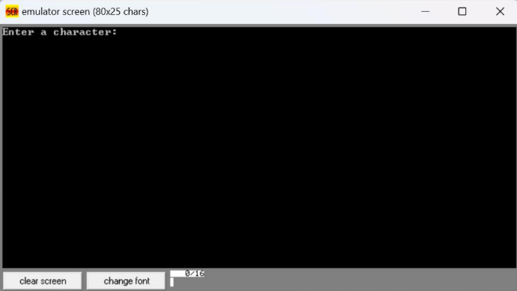Displaying a String:

